Tkinter : It’s a python In-built module used for creating GUI (Graphic User Interface ) experience for the apps

GUI is nothing but visual indicators where users can interact visually with electronic devices

Math : It’s a python In-built module used for using math functions in the program /app

***THE REASON OF CREATING AND OPTIONS PROVIDED***

This is a **Scientific Calculator** with functions addition, Subtraction , multiplication , division , sin , cos , tan, percentage , logarithm , natural logarithm and power of number . The speciality of the app is that it can take input upto infinity and give output upto infinity which most of the calculators do not support

ex.(the Microsoft calculator, Mobile Calculator)

INPUT & OUTPUT :

ADDITION :

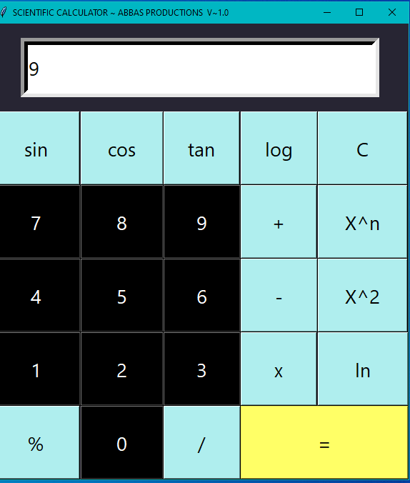 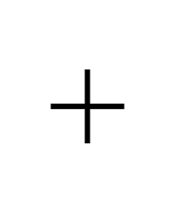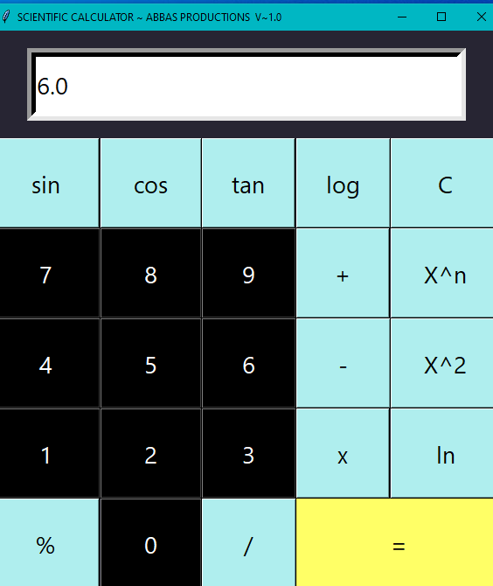

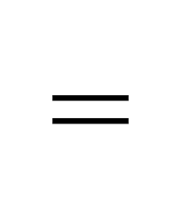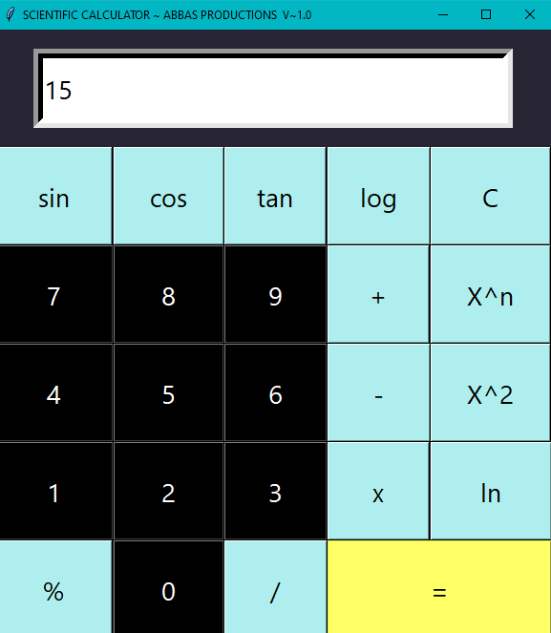

SUBTRACTION:





MULTIPLICATION :

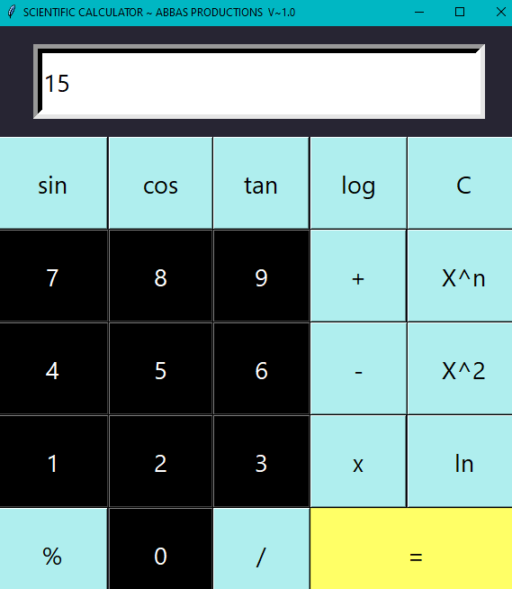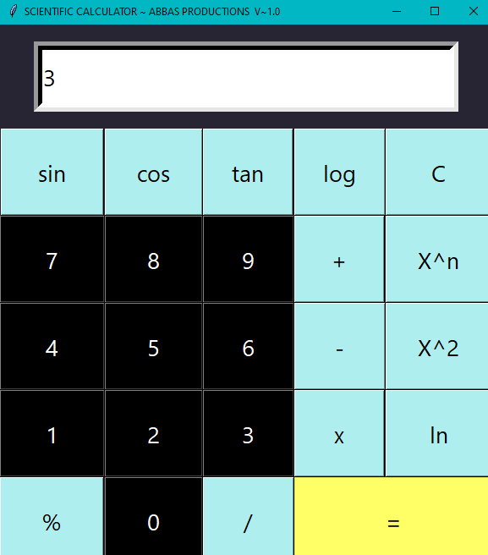

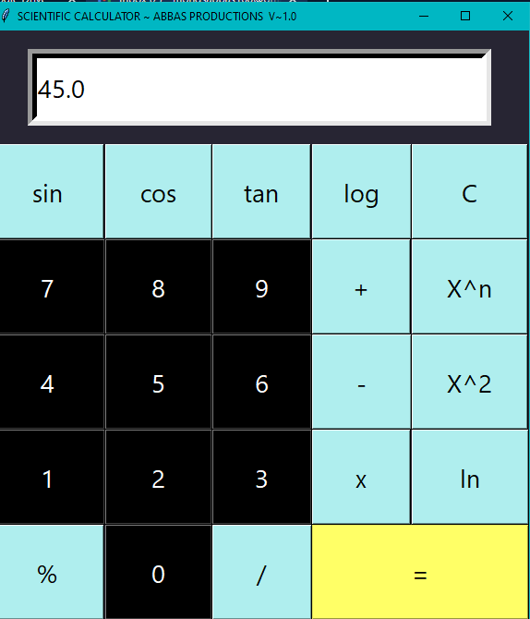

SIN :

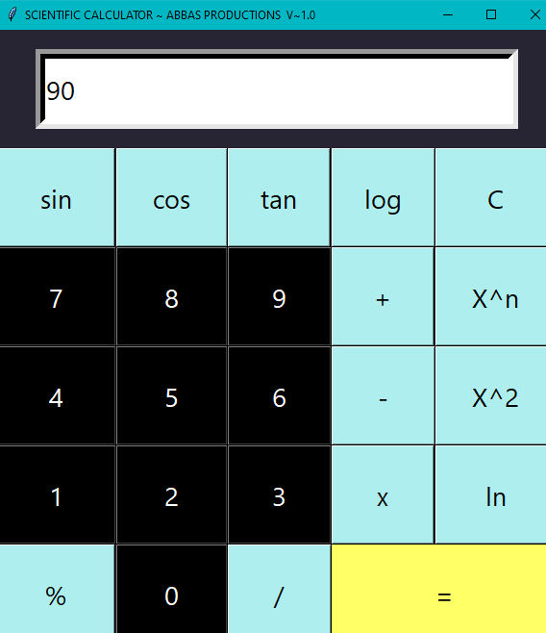 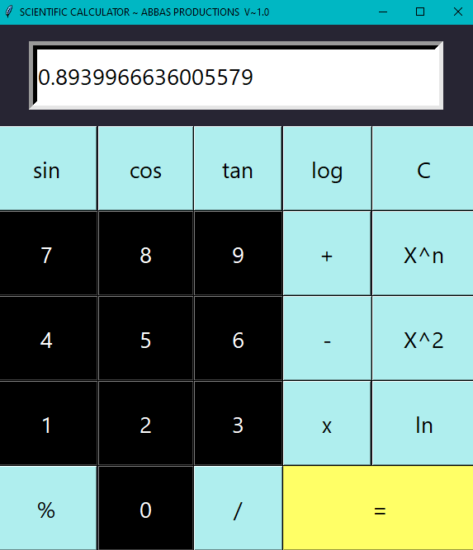

COS :

